

**CSCU9N6 – 2D Platform Game Assignment 2019**

Student ID: 2520796

# **Give a brief summary of the game play.**

When I firstly read the assignment couple of old games came to my mind, mostly retro ones from the 80s that I used to play when I was a kid in a console like Super Mario, Wonder Boy, Sonic, Metal Slug, Lara Croft etc. These games were the inspiration for the creation of Larry Croft. The gameplay focuses around action 2D adventure exploration with environmental traps and fighting with numerous enemies. Larry is the main character(player) and an archeologist that wants to explore the ancient tombs and discover the secrets, lost artifacts and relics that are hidden into the hazardous ruins full of enemies, traps and bosses. Larry’s journey starts in a temple which after years he finally found the entrance into the ruins as the screenshot below shows the starting point of the game.

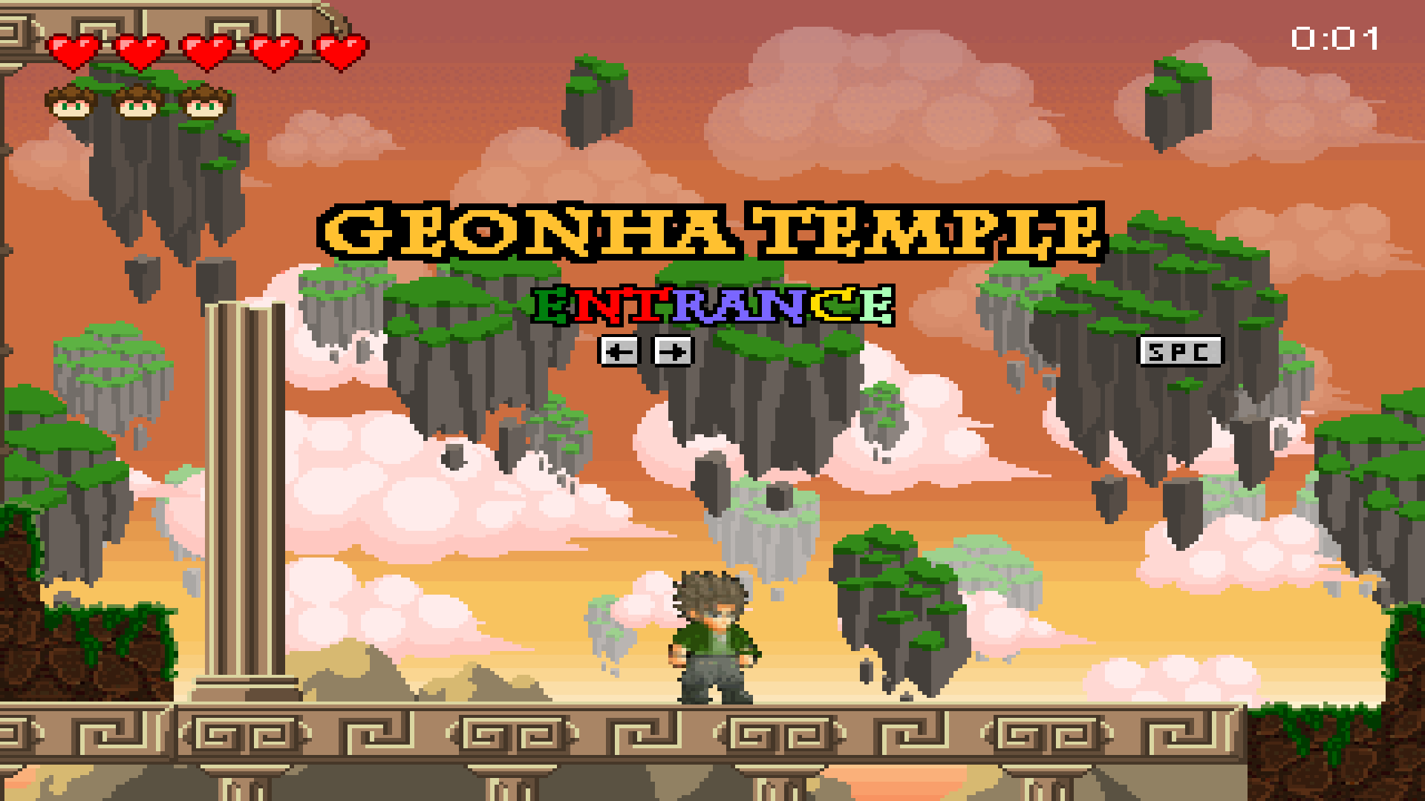

* The player has 5 hearts. That means if the player got hit from enemies, he loses one heart and if he receives damage 5 times he dies and lose one life.
* If a player falls from the edge, he instantly loses 1 life and restarts again from the beginning of the current stage.
* After the player finish a stage the hearts are restored to 5.
* If a player loses all the lifes the game will over, and he can start again the game from the stage 1.
* The user can use the keys from the keyboard to make the player move, jump, attack:
  + **Left/Right Arrow =** Walk Left/Right
  + **Space =** Jump (as long the Space key is pressed the highest the jump will be)
  + **Space + Space =** Double Jump
  + **Z =** Slash Attack
  + **X =** Charge Attack
  + **Up Arrow + Z =** Upper Attack
  + **Ctrl + Left/Right Arrow =** Run Left/Right
  + **Esc =** Pause**/**Menu UI

# **Discuss how your prototype game was implemented and how it could be extended from a software implementation point of view.**

The very first stage of my prototype implementation was to think about a story of the game, e.g. who is going to be the player main character, how many enemies and what kind of enemies are going to be, what the background should be, the game mechanics, the animations, the characters and environmental objects in general, sprites, sounds, images, tile sets and the user interface. After I figure out all the above, I got an early feedback from potential users that were interested in my game giving me ideas so I can have a very clear understanding of the game concept and content. Furthermore, I spend multiple hours to polish an already existing application which it reads the imported tile set and allows the user to click on a box(e.g dirt box) in the current tile set to select it and simply draw the map while at the same time the application exports the exact position of the mouse (e.g. 302-Xpixels, 1002-Ypixels, 10-Column, 17-Row). The mouse position will help later for the exact spawn position of enemies and player. The Column and Row position it will help to determine the difficulty of each stage. For example, the player can jump up to 10 blocks while running. Knowing this I could calculate the distance of each jump and the difficulty of the stage. Furthermore, the visual representation of each stage is incredibly helpful and inspiring for the storyline of the game which allows less mistakes than hard coding a text file guessing everything. Below is a screenshot with a visual representation of the Stage 1 of the game, with the current tile set (down left).

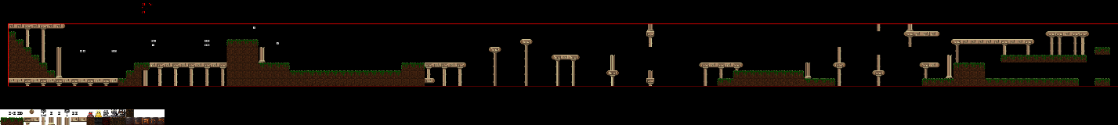

The creation of a game it can be very complex by hard coding everything. There are a lot of tools that can be used to help the game designers and game engines are one of them. A game engine is a software that provides lot of essential set of features to build a game rapidly and professionally for example rendering graphics, collision detection, animation features, AI features, memory management, physics and many more. This is a very good and efficient way to extend a game 2D or 3D as it will provides amazing results in a very little time in comparison with hard coding. Some of the most popular game engines are Unity, Unreal, CryEngine and GameMaker.

# **Discuss how you would add further functionality to your game given extra time and honestly evaluate your application and point out where you think it was successful and where it needs improvement.**

This game has 3 stages. Stage1(Temple), Stage2(Underground ruins), Stage3(Boss).

Based on my prototype, some of the functionalities that I would like to add are:

* **Score** (take points for killing enemies, collecting coins and relics)
* **Leaderboard** (save the score)
* More **collision triggers** for example activate a trap while passing a specific point/block/pixel coordinate.
* **Add more attacks** (I already have a Fireball class, tile set, sprites for a throwing fireball attack which is a range attack but due time this function is still unfinished so it will not appear in the game)
* **More stages**
* **Stage selection function**
* **Save/Load game function**
* **More kind of enemies**
* **NPCs with dialogs and missions** (this will improve the quality of the storyline and it will make it more interesting for the user)
* **Items for interaction** (e.g. Checkpoints, Power ups, Level ups, +1 life items, Health Potions)

Based on the time given, I spend huge amount of time and effort for this application due to my passion for games. However, the evaluation for this project it can be considered as “Good”. I am happy but not completely satisfied of the results as I wish I had the time to add more functions I mentioned above. Although I received very positive feedbacks from my testers, most of them declared that the game is very difficult even from the 1st level. I understand that I made this application based on my personal experience in games without considering the gaming expertise of all the other people and this is the most crucial part that needs improvement.

On the other hand, some of the successful parts of this game are the attractive colours, the theme-based backgrounds, animations, sprites, the User Interface and the smoothness of the game. But the most successful part of the game is the size of each stages. It allows and challenges the user to spend some time exploring the stage, fight with enemies and discover secret paths.

Bellow there is a cloud link of a small video game-playthrough that I did after a lot of requests due to the difficulty of the stages:

<https://drive.google.com/drive/folders/1B5hmA7pdtkfJvaSLFEfPHgJLlR4AwinF?usp=sharing>

# **Applications-Tools-Assets Used:**

* + Paint.net
  + <https://www.piskelapp.com/>
  + TileMapEditor software
  + WillRock game (background music)
  + Little Fighter 2 game (sprites, sound effects)
  + Eclipse IDE
  + Photoshop
  + Reaper DAW